By
H. M. Faisal

Lab Manual
Computer Organization and Assembly Language

A simplified practical work book of Assembly Language course for Computer Science, CS, IT and Software Engineering students

Lab Manual Computer Organization and Assembly Language: First Edition

Student Name:______________________________________
Registration No:___________________________________
Section / Semester: _________________________________
Submission Date: _____________________________________
Student Signature: __________________________________

Marks Obtained: _______________________________________
Maximum Marks: _____________________________________
Examiner Name/Sig: ___________________________________

H. M. Faisal Chughtai

(Publisher:???)
Author(s): H. M. Faisal Chughtai
ISBN: ????
Publication Date: ????
A publication of BIIT Series
Copyrights © Reserved By Authors

Learning Objectives: By the end of the lab work, students should have following skills;

Sr. | Learning Objective | LAB No.
1 | General information about assembly language and 8086 emulator. | 01
2 | MOV instruction& XCHG instruction | 02
3 | Displaying messages & Prompt from user | 03
4 | Arithmetic instructions | 04
5 | Printing Patterns | 05
6 | Conditional Jumps & Loop | 06
7 | Logic Instructions  Shift Instructions & Rotate Instructions | 07
8 | Binary I/O & HEXA I/O | 08
9 | Stack | 09
10 | Procedures | 10
11 | Decimal I/O  LCM & GCD | 11
12 | DUP Operator & Array | 12
13 | Strings | 13
14 | MACROS & Label Conflict | 14
15 | Inline Assembly | 15
16 | Recursion | 16

Table of Contents
LAB # 1 5
Theory: Assembly Language 5
Task 1.1: Familiarity with 8086 Emulator 5
LAB # 2 8
Theory: Basic Instructions 8
Task 2.1: Programing Practice 8
LAB # 3 10
Theory: Programs with Basic Instructions 10
Task 3.1: Programming Practice 10
LAB # 4 12
Theory: Add, Sub, Inc and Dec Instructions 12
Task 4.1: Programming Practice 12
12
LAB # 5 13
Theory: Basic Programs 13
Task 5.1: Programming Practice 13
Assignment # 1 14
14
LAB # 6 15
Theory: Conditional Statements 15
Task 6.1: Programming Practice 15
LAB # 7 22
Theory: Logical, Shift and Rotate Instruction 22
Task 7.1: Programming Practice 23
LAB # 8 26
Theory: Number System Conversions 26
Task 8.1: Programming Practice 26
Assignment # 2 28
LAB # 9 30
Theory: Stack 30
Task 9.1: Programming Practice 30
LAB # 10 31
Theory: Procedures 31
Task 10.1: Programming Practice 31
LAB # 11 33
Theory: Decimal I/O 33
Task 11.1: Programming Practice 33
Mini Project: 36
LAB # 12 39
Theory: DUP Operator and Arrays 39
Task 12.1: Programming Practice 40
LAB # 13 45
Theory: String Instruction 45
Task 13.1: Programming Practice 45
LAB # 14 52
Theory: Macros and Label Conflict 52
Task 14.1: Programming Practice 52
LAB # 15 54
Theory: Inline Assembly 54
Task 15.1: Programming Practice 54
LAB # 16 58
Theory: Recursion 58
Task 16.1: Programming Practice 58
59
Bibliography 60

LAB # 1

Theory: Assembly Language
Assembly language is a symbolic representation of a processor's native code. Using machine code allows the programmer to control precisely what the processor does. It offers a great deal of power to use all of the features of the processor. The resulting program is normally very fast and very compact. In small programs timing is also very predictable.

Task 1.1: Familiarity with 8086 Emulator

This section elaborates the environment of software tool to be used in LAB. Note that actually you may use an updated version of the software tool.

- Start Emu8086 by selecting its icon from the start menu, or by running
- Emu8086.exe.
- Select "Samples" from "File" menu.
- Click [Compile and Emulate] button (or press F5 hot key).
- Click [Single Step] button (or press F8 hot key), and watch how the codeis being executed.

Step 1:

- Click on start
- Type “emu8086”
- Click on the icon as shown in figure 1

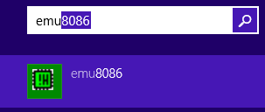

Figure 1
Step 2:

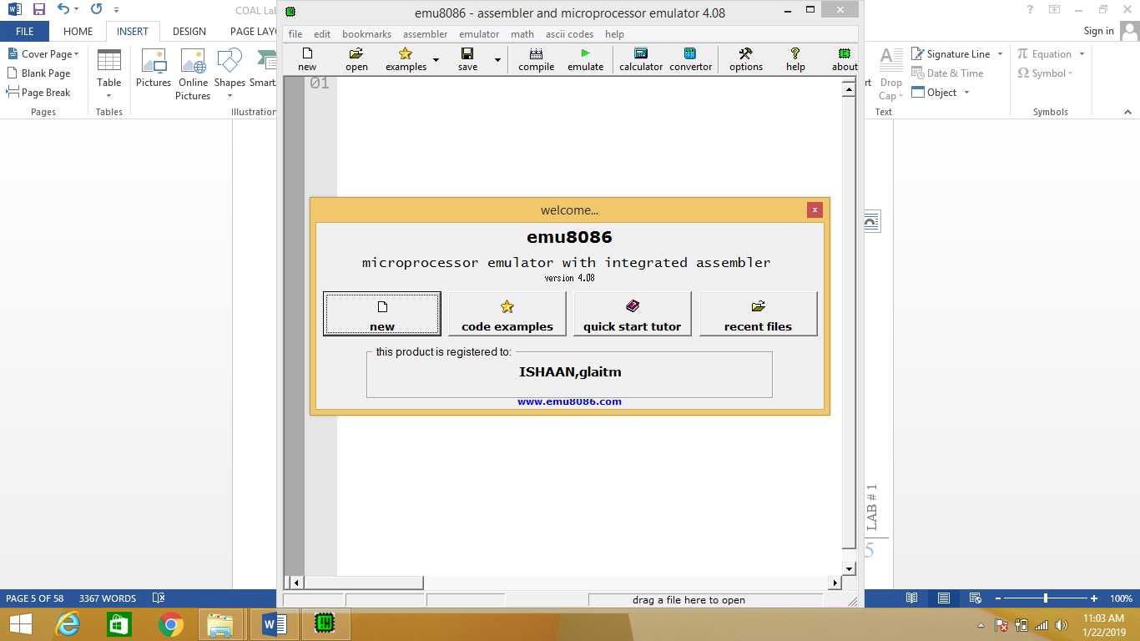
Figure 2
Step 3:
- Basic Structure
- And emulate

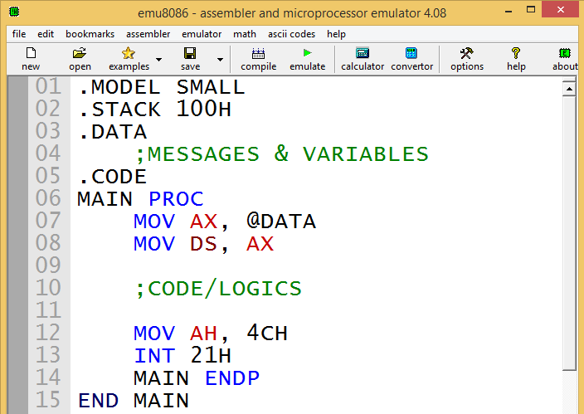

Figure 3

Step 4:
- Run
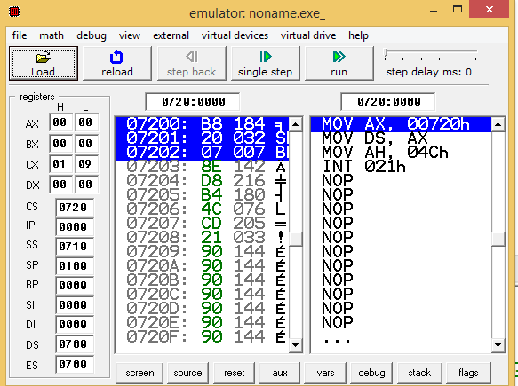

Figure 4

Step 5:
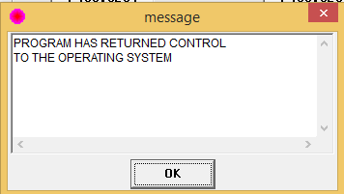

Figure 5

Step 6:
- Output

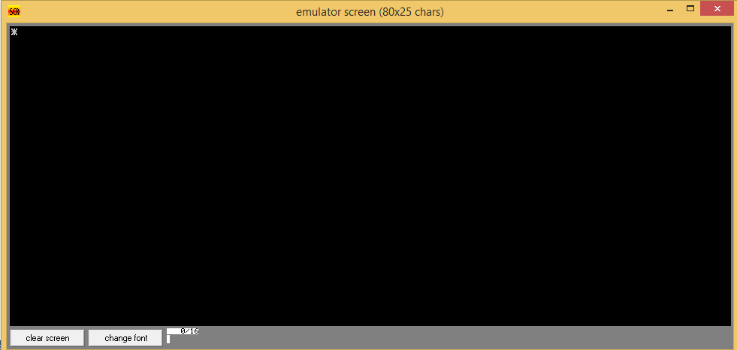

Figure 6

Comments/Signature (Student & Teacher):

LAB # 2

Theory: BasicInstructions
The MOV Instruction is used to transfer data between register, between a register and a memory location, or to move a number directly into a register or memory location. The syntax is:
MOV destination, source

The XCHG (exchange) operation is used to exchange the contents of two registers, or a register and a memory location. The syntax is:
XCHG destination, source

In this lab you will practice to learn MOV and XCHNG Instructions in 8086.

Task 2.1: Programing Practice

- Write a complete program to do the following.

- Write a code that will input a character from user and will display it on the same line at next position.

Sample Execution:
ENTER A CHARACTER: A
A
- Write a code that will input an uppercase letter from user and will display it at next position on the same line.
Comments/Signature (Student & Teacher):

LAB # 3

Theory: Programs with Basic Instructions
MOV AH, 1 is used for taking input from user and MOV AH, 2 is used for displaying output.

Task 3.1: Programming Practice

- Write a Program to that will display a “?” and will input two decimal digits whose sum is less than 10 and will also display them and their sum on the next line, with an appropriate message.

Sample execution:

?27
THE SUM OF 2 AND 7 IS 9

- Write a program to input three initials, read first, middle, and last initial of a person’s name and display them down the left margin.

Sample execution:

ENTER THREE INITIALS: JFK
J
F
K
Comments/Signature (Student & Teacher):

LAB # 4

Theory: Add, Sub, Inc and Dec Instructions
The ADD and SUB instructions are used for performing simple addition/subtraction of binary data in byte, word and double word size, i.e., for adding or subtracting 8-bit, 16-bit or 32-bit operands, respectively.
The INC instruction is used for incrementing an operand by one. It works on a single operand that can be either in a register or in memory.
The DEC instruction is used for decrementing an operand by one. It works on a single operand that can be either in a register or in memory.

Task 4.1:Programming Practice

- Write a program to input one of the hex digits A-F, convert it into decimal and display it on the next line.
Sample execution:
ENTER A HEX DIGIT: C
IN DECIMAL IT IS 12
Comments/Signature (Student & Teacher):

LAB # 5

Theory: Basic Programs

Task 5.1: Programming Practice

- Write a program that will display a 10 x 10 solid box of asterisks.

Hint: Declare a string in the data segment that specifies the box, and display it with INT 21h.

Sample execution:

**********
**********
**********
**********
**********
**********
**********
**********
**********
**********

Assignment # 1

- Write a program that will display “?”, read three initials and will display them in the middle of an 11 x 11 box of asterisks, also beep the computer.
Sample execution:
?JFK
**********
**********
**********
**********
**********
***JFK****
**********
**********
**********
**********
**********
Comments/Signature (Student & Teacher):

LAB # 6

Theory: Conditional Statements
- Conditional Jumps :
JNZ is an example of a conditional jump instruction.
The syntax is:

JNZ destination
- The JMP Instruction:
The JMP (jump) instruction causes an unconditional transfer of control. (Unconditional jump)
The syntax is:
JMP destination

Task 6.1: Programming Practice
- Write a program that will take input a letter from user. If it is an upper case, the program will display it otherwise program will terminated.

Sample Execution:
ENTER A LETTER: A
A
ENTER A LETTER: a

- Write a program that will take input a letter from user. If it is “y” or “y”, the program will display it otherwise program will be terminated.

Sample Execution:
ENTER A LETTER: Y
Y
ENTER A LETTER: y
y
ENTER A LETTER: A

- Write a program that will display a row of 80 asterisks.
Hint: Use count-controlled loop.

- Write a program that will count number of characters in a line inserted by user and will display it.

Sample Execution:
ENTER A LINE: ASSEBLY LANGUAGE
NUMBER OF CHARACTERS IN “ASSEMBLY”ARE 8

- Write a program that will take input from user until user inputs a blank. When user inputs a blank program should terminate.

- Write a program that to display the extended ASCII characters (ASCII codes 80h to FFh). Display 10 characters per line, separated by blanks. Terminate the program after the extended characters have been displayed once.

- Write a program that will prompt the user to enter a hex digit character ("0"· ... "9" or "A" ... "F"), display it on the next line in decimal, and ask the user if he or she wants to do it again. If the user types “y” or “Y”, the program repeat, if the user types anything else, the program terminates. If the user enters an illegal character, prompt the user to try again.

Sample Execution:

ENTER A HEX DIGIT: 9
IN DECIMAL IT IS 9

ENTER A HEX DIGIT: A
IN DECIMAL IT IS 10

DO YOU WANT TO ENTER AGAIN?
Comments/Signature (Student & Teacher):

LAB #7

Theory: Logical, Shift and Rotate Instruction
AND, OR, and XOR INSTRUCTION:
The AND, OR, and XOR instructions perform the named logic operations.
THE formats are:
AND destination, source
OR destination, source
XOR destination, source

- Shift Instructions:

Shift Left (SHL):
The SHL (shift left) instruction shifts the bits in the destination to the left. The format for a single shift is SHL destination, 1

Shift Right (SHR):
The instruction SHR (shift right) performs right shifts on the destination operand. The format for a single shift is
SHR destination, 1

Shift Arithmetic Right (SAR):
The SAR Instruction (shift arithmetic right) operates like SHR, with one difference: the msb retains its original value.
The syntax is
SAR destination, 1

- Rotate Instructions:

Rotate Left (ROL):
The instruction ROL (rotate left) shifts bits to the left. The msb is shifted into the rightmost bit. The CF also gets the bit shifted out of themsb. You can think of the destination bits forming a circle, with the leastsignificant bit following the msb in the circle.
The syntax is:
ROL destination, 1
and ROL destination, CL

- Rotate Right (ROR):
The instruction ROR (rotate right) works just like ROL, except that the bits are rotated to the right. The rightmost bit is shifted into the msb, and also into the CF.
The syntax is:
ROR destination, 1
And ROR destination, CL

- Rotate Carry Left (RCL):
The Instruction RCL (Rotate through Carry Left) shifts the bits of the destination to the left. The MSB is shifted Into the CF, and the previous value of CF is shifted into the rightmost bit. In other words, RCL works like just like ROL, except that CF is part of the circle of bits being rotated.
The syntax is:
RCL destination, 1
AND RCL destination, CL

- Rotate Carry Right (RCR):
The instruction RCR (Rotate through Carry Right) works just like RCL, except that the bits are rotated to the right See Figure. The syntax is:
RCR destination, 1
AND RCR destination, CL

Task 7.1: Programming Practice
Q.1 Write an assembly language code to print whether the number is even positive or even odd and odd positive or odd negative.
Sample Execution:
ENTER NUMBER: 8
IT IS EVEN POSITIVE

Q.2 Write an assembly language code that will display number of 0’s and 1’s in a character entered by a user.

Sample Execution:
ENTER CHARACTER: A
NUMBER OF 1’s ARE 2
NUMBER OF 0’s ARE 6
Comments/Signature (Student & Teacher):

LAB # 8

Theory: Number System Conversions
Practice the code of Binary Input, Binary Output, Hexa Input, Hexa Output and perform the following tasks.

Task 8.1: Programming Practice
Q.1. Write an assembly language code that will input a hex digit from user and will convert it into binary and will also display it in binary.
Sample Execution:
ENTER A HEX DIGIT: A
IN BINARY IT IS: 01000010

Q.2. Write an assembly language code that will input a binary number from user and will convert it into hex digit and will also display it in hex digit.
Sample Execution:
ENTER BINARY: 01000010
IN HEXA IT IS: A

Assignment # 2

Q.1 Write a program that will take binary input from user and will also display it.

Q.2 Write an assembly language code that will take Hexa input from user and will also display it.

Comments/Signature (Student & Teacher):

LAB # 9

Theory: Stack
A stack is one-dimensional data structure. Items are added and removed from one end of the structure; that is, it is processed in a "last-in, first-out" manner. The most recent addition to the stack is called the top of the stack. A familiar example is a stack of dishes; the last dish to go on the stack is the top one, and it's the only one that can be removed easily.

A program must set aside a block of memory to hold the stack. We have been doing this by declaring a stack segment:
For example:
.STACK 100H

Task 9.1: Programming Practice
Q.1 Write an assembly language code that will input a string from user and will display it in reverse order on next line.
Sample Execution:
ABCDEFGH
HGFEDCBA
Comments/Signature (Student & Teacher):

LAB # 10

Theory: Procedures

One of the procedures is the main procedure, and it contains the entry point to the program. To carry out a task, the main procedure calls one of the other procedures. It is also possible for these procedures to call each other, or for a procedure to call itself.
When one procedure calls another, control transfers to the called procedure and its instructions are executed; the called procedure usually returns control to the caller at the next instruction after the call statement.

Procedure Declaration:
The syntax of procedure declaration is the following:
Name PROC type
; Body of the procedure
RET
Name ENDP
RET:
The RET (return) instruction causes control to transfer back to the calling procedure. Every procedure (except the main procedure) should have a RET someplace; usually it's the last statement in the procedure.

Task 10.1: Programming Practice

IMPLEMENT THIS CODE AND SHOW THE RESULT.

.MODEL SMALL
.STACK 100H
.CODE
MAIN PROC
CALL PRINTSTAR

MOV AH, 4CH
INT 21H

MAIN ENDP

PRINTSTAR PROC
MOV CX, 10
MOV AH, 2
MOV DL, '*'

PRINT:
INT 21H
LOOP PRINT
RET

PRINTSTAR ENDP

Q.1 Write an assembly language code that will display 10x10 boxes of asterisks (*) by using procedures.

Comments/Signature (Student & Teacher):

LAB # 11

Theory: Decimal I/O
Decimal Input and Output Procedures:
Even though the computer represents everything in binary, it's more convenient for the user to see input and output expressed in decimal In this section, we write procedures for handling decimal I/O.

Task 11.1: Programming Practice

Q.1 Write assembly language code that will take Decimal input from user and will display it.

Hint: Use Procedures of DECIN and DECOUT

Q.2 Write assembly language code that will calculate LCM of two numbers and will display it.

Sample Execution:
ENTER FIRST NUMBER: 2
ENTER SECOND NUMBER: 5
LCM= 10

Q.3 Write assembly language code that will calculate GCD of two numbers and will display it.

Mini Project:

Write a complete assembly language program that will make following conversions with proper menu:
- Binary to Binary
- Binary to Hexa
- Binary to Decimal
- Hexa to Hexa
- Hexa to Binary
- Hexa to Decimal
- Decimal to Decimal
- Decimal to Binary
- Decimal to Hexa

Comments/Signature (Student & Teacher):

LAB # 12

Theory: DUP Operator and Arrays
One-Dimensional Arrays:
A one-dimensional array is an ordered list of elements, all of the same type. By “ordered,” we mean that there is a first element, second element, third element, and so on. In mathematics, if A is an array, the elements are usually denoted by A[1], A[2], A[3] and so on.

The Dup Operator:
It is possible to define arrays whose elements share a common initial value by using the DUP (duplicate) operator. It has this form:
Repeat_count DUP (value)

This operator cause’s value to be repeated the number of times specified by repeat_count. For example:
GAMMA DW 100 DUP (0)

Sets up an array of 100 words, with each entry initialized to 0. Similarly,
DELTA DB 212 DUP (?)

Creates an array of 212 uninitialized bytes. DUPs may be nested. For Example:
LINE DB 5,4, 3 DUP (2,3 DUP (0),1)
Which is equivalent to:
LINE DB 5,4,2,0,0,0,1,2,0,0,0,1,2,0,0,0,1

Task 12.1: Programming Practice

Task 1. Write a code that will add elements of an array and will display their sum.

Task 2.Write code that will calculate average of an array and will also display it.

Task 3.Write an Assembly Language code to search a number in an Array.

Task 4.Write an Assembly Language code to print number of occurrence of a number in an Array.

Assignment # 3
Q.1.Write an Assembly Language code to print minimum and maximum number in Array.

Comments/Signature (Student & Teacher):

LAB # 13

Theory: String Instruction
The STOSB Instruction moves the contents of the AL register to the byte addressed b ES:DI. DI is incremented if DF=0 or decremented if DF=1. Similarly, the STOSW instruction moves the contents of AX to the word at address ES:DI and updates DI by 2, according to the direction flag setting.

Task 13.1: Programming Practice

Task 1. Write assembly language code to take input a string from user and display it on next line..

Sample Execution:
ENTER STRING: ABCDEFGH
ABCDEFGH

Task 2. Write assembly language code that reverses the string.

Task 3. Write an assembly language code that will copy the string in same string.

Task 4. Write an assembly language code that will reverse the string in same string.

Task 5.Write an assembly language code that finds length of a string.
Sample Execution:
ENTER STRING: ABCDEFGHIJKL
LENGTH IS: 12

Task 6.Write an assembly language code that removes spaces in the string.

Sample Execution:
ENTER STRING: A B C D E F G H
HGFEDCBA

Task 7. Write an assembly language code that prints no. of vowels and consonants in string.
Sample Execution:
ENTER STRING: ABCDEFGHijklmno
VOWELS: 4
CONSOTANTS: 11

Comments/Signature (Student & Teacher):

LAB # 14

Theory: Macros and Label Conflict
A macro is a block of text that has been given a name. When MASM encounters the name during assembly, it inserts the block into the program. The text may consist of instructions, pseudo-ops, comments, or references to other macros.

The syntax of macro definition is:
Macro_name MACRO d1, d2, . . . dn
Statements
ENDM
A macro with a loop or decision structure contains one or more labels. If such a macro is Invoked more than once In a program, a duplicate label appears, resulting in an assembly error: This problem can be avoided by using local labels In the macro. To declare them, we use the LOCAL pseudo-op, whose syntax is:
LOCAL list_of _ labels

Where list_of_labels is a list of labels, separated by commas. Every time the macro is expanded, MASM assigns different symbols to the lab('!s in the list.
The LOCAL directive must appear on the next line after the MACRO statement.

Task 14.1: Programming Practice
Task 1: Write assembly language code of macros.

Task 2: Write assembly language code that define label conflict.
Comments/Signature (Student & Teacher):

LAB # 15

Theory: Inline Assembly
The inline assembler is a feature of some compilers that allows very low level code written in assembly to be embedded in a high level language.

Task 15.1: Programming Practice
Task 1.Write inline assembly code to print factorial of a number.

Task 2. Write inline assembly code of printing power of number.

Task 3. Write inline assembly code of calculating Arithmetic operations with proper Menu.

Comments/Signature (Student & Teacher):

LAB # 16

Theory: Recursion

A recursive procedure is a procedure that calls itself. Recursive procedures are important in high-level languages, but the way the system uses the stack to implement these procedures is hidden from the programmer. In - assembly language, the programmer must actually program the stack operations. So this provides, an opportunity to see how recursion really works.

Task 16.1: Programming Practice

Task 1. Write assembly language code of calculating factorial of a number by using recursive procedures.

Task 2. Write assembly language code of calculating sum of a number by using recursive procedures.
Sample Execution:
?3
Sum = 6
(3 + 2 + 1)
Comments/Signature (Student & Teacher):

Bibliography
Information about the Lab Manual, and major topics covered in the Labs and Assignments

H.M. Faisal Chughtai– currently working as a lecturer at University Institute of Information Technology, Pir Mehr Ali Shah-Arid Agriculture University Rawalpindi.

